**STA 6106 - Final Project**

**By: Anmol Sureshkumar Panchal;  UID: 4446829**

Submitted on 12/04/2018 : 15:25:30 PM

**Problem 1:**

**Explanation with the Code:**

Lets Load the required packages to perform hyper tuning of the parameters for the dataset **“pb2.txt”** as **class = V1 =1** for problem 1 and also for performing stepwise regression in forward direction using the same class of the same dataset.

library(caret)  
library(leaps)  
library(MASS)  
library("e1071")  
  
################### PROBLEM 1 ###############################

Here below the code lines import the dataset and store it in pb2 as data frame.

pb2 <- read.table("C:/Users/anmol/Downloads/pb2.txt")  
data<-  data.frame(pb2)  
print(data)

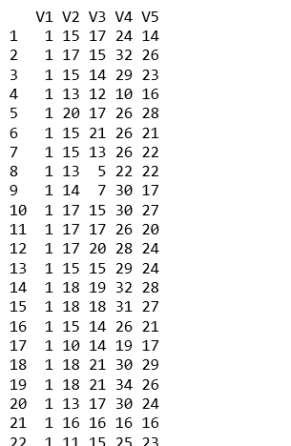

Here below we are going to hyper tune and fit svm model using **tune.svm** with multiple cost parameters and gamma values. The model tunes the svm for each of the value and then selects the best value possible for the model. We will then print the model and also summarize and plot the model using **summary(), plot().**

model <- tune.svm(V1 ~ 1., data = data,  kernel='radial', cost=c(0.1,1,10,100,1000),gamma=c(0.5, 1,2,3,4))

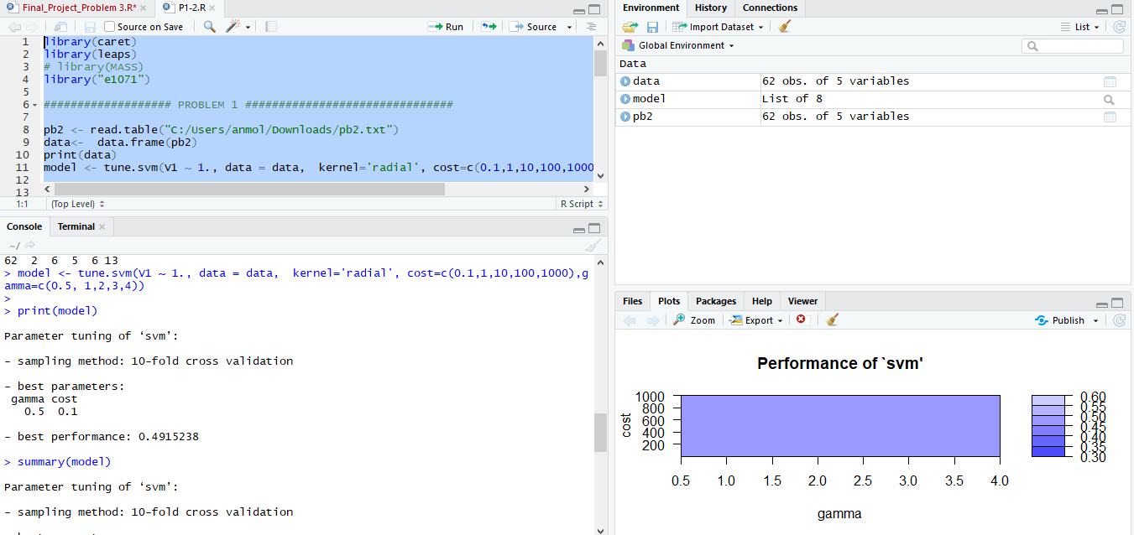

print(model)  
summary(model)

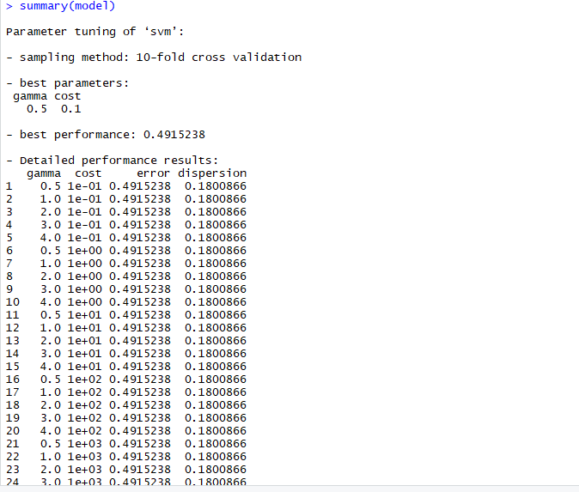

plot(model)

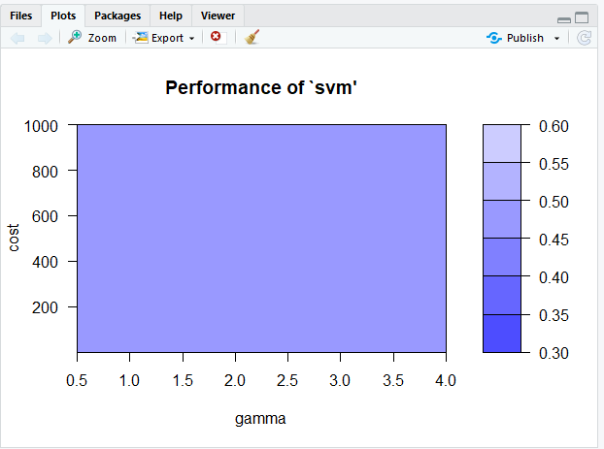

**Problem 2:**

**Explanation with the Code:**

Now we will proceed to solve the Problem 2 where we need to perform the step wise regression of our dataset with **class = V1= 1** in forward direction.

In stepwise regression, we pass the full model to step function. It iteratively searches the full scope of variables in backwards directions by default, if scope is not given. It performs multiple iteractions by droping one X variable at a time. In each iteration, multiple models are built by dropping each of the X variables at a time. The AIC of the models is also computed and the model that yields the lowest AIC is retained for the next iteration.

In simpler terms, the variable that gives the minimum AIC when dropped, is dropped for the next iteration, until there is no significant drop in AIC is noticed.

The code below shows how stepwise regression can be done. In forward stepwise, variables will be progressively added.

Here we are declaring a model min.model and performing regression using **lm()** with our class as given “1” and data as (V2,V3,V4,V5).

The stepwise regression (or stepwise selection) consists of iteratively adding and removing predictors, in the predictive model, in order to find the subset of variables in the data set resulting in the best performing model, that is a model that lowers prediction error.

There are three strategies of stepwise regression (James et al. 2014,P. Bruce and Bruce (2017)) one of the Strategy which we are focused on is Forward Selection.

Forward selection, which starts with no predictors in the model, iteratively adds the most contributive predictors, and stops when the improvement is no longer statistically significant.

min.model = lm(data$V1 ~ 1)  
min.model = lm(data$V1 ~ 1, data=data)

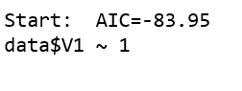

Now we are going to specify the forward stepwise model **fwd.model using step()** giving model , direction and scope. An then print summary of our model and see the Coefficient Intercept.

fwd.model = step(min.model, direction='forward', scope=(~ .))  
summary(fwd.model)

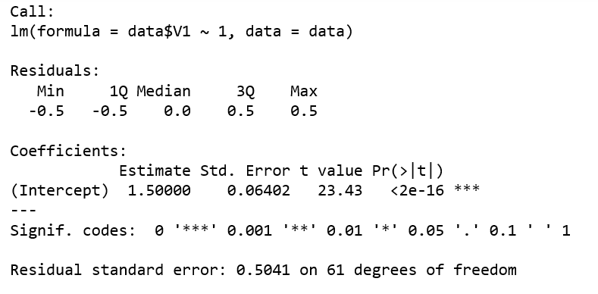

Now we are going to do the same thing but with different approach by updating at each step as we go for forward selection taking first V1 then updating subsequent columns/ features V2, V3,V4,V5 as shown below.

g <- lm(V1~. , data=data)  
summary(g)

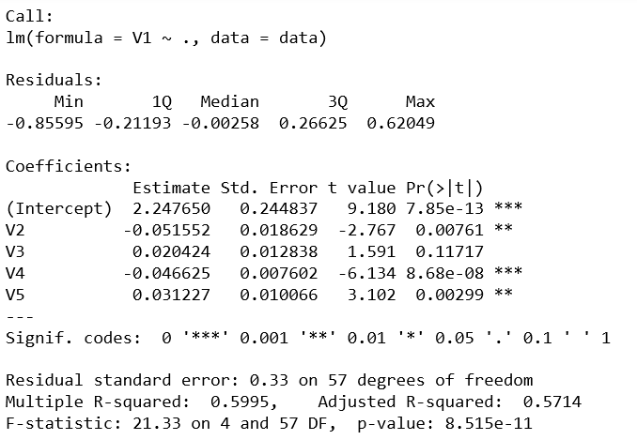  
  
g <- update(g, . ~ . - V1)  
g

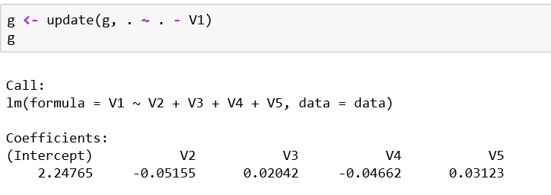

g <- update(g, . ~ . - V2)  
g  
  
g <- update(g, . ~ . - V3)  
g

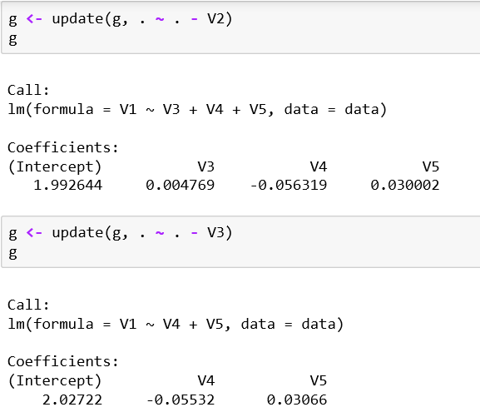

g <- update(g, . ~ . - V4)  
g  
  
g <- update(g, . ~ . - V5)  
g

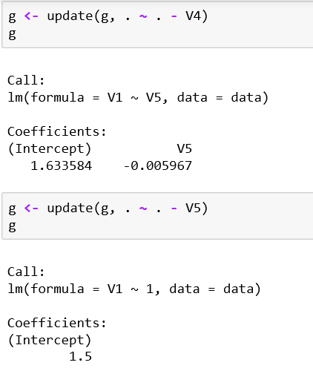

As we see we remain with one intercept value after updating V5 above which matches the earlier model which we extracted intercept by using step() directly. In Forward selection, which starts with no predictors in the model, iteratively adds the most contributive predictors, and stops when the improvement is no longer statistically significant. Hence remaining with a single intercept coefficient value at the end.

I will show you again our above g model using step and its stats.

step(g , direction = "forward")

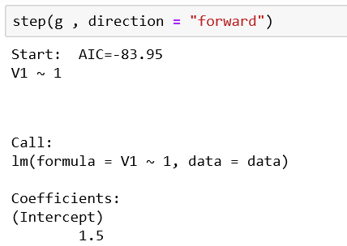

Now we will Plot the g model we created. The first plot shows the the theoretical quantiles against std. residuals. Second plot shows the scaling of the location of the class against sqrt of residuals.

plot(g)

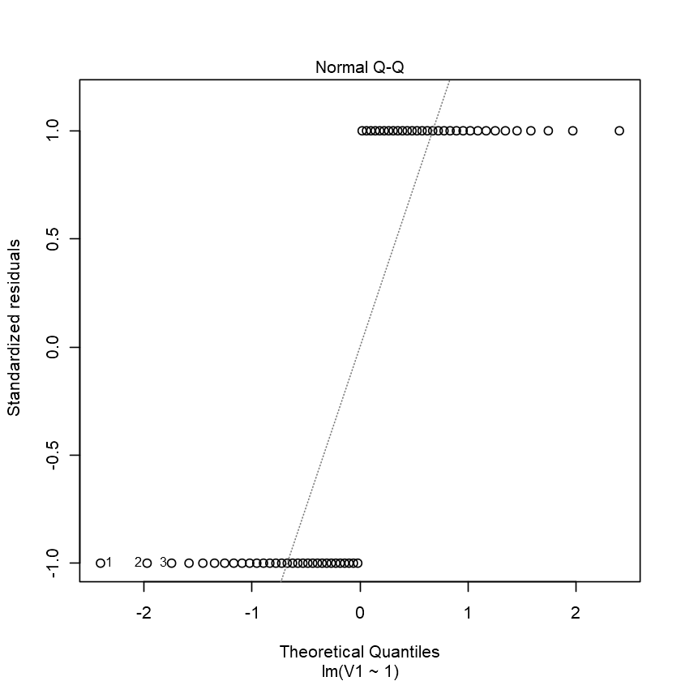  
  
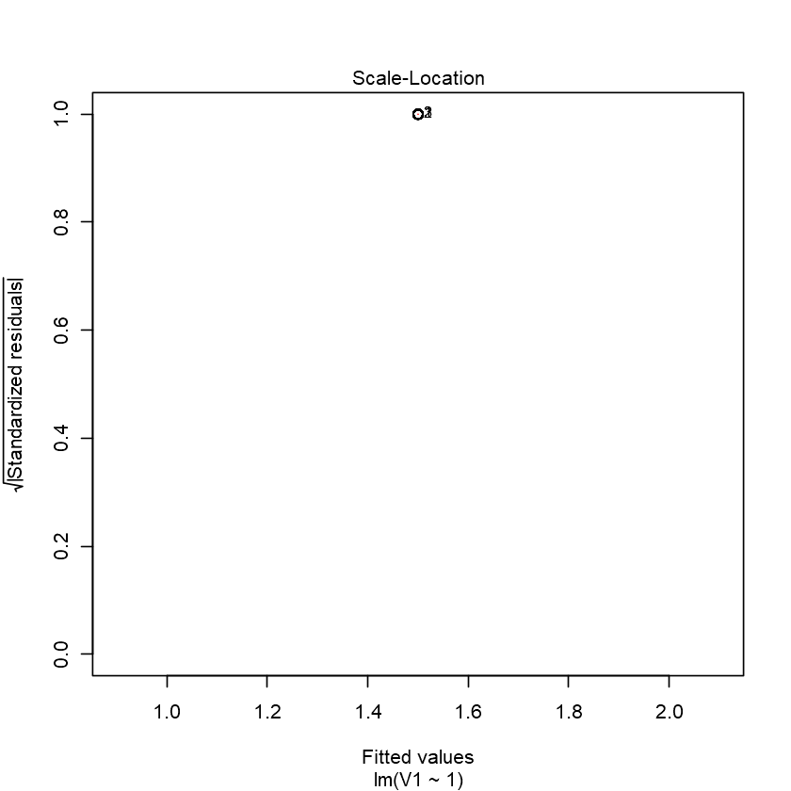

**Problem 3: PART b) Deep Learning SVDD.**

Modeling For modeling, I am using R’s H2O implementation with the h2o package. For more details and other examples, see posts of machine learning webinar (https://shiring.github.io/machine_learning/2017/03/31/webinar_code), on building neural nets with h2o (<https://shiring.github.io/machine_learning/2017/02/27/h2o>).

First load the packages we will require tidyverse, h20 , anomaly.

library(tidyverse)

library(h2o)

library(anomaly)

Now we need to import our dataset.

pb2 <- read.table("C:/Users/anmol/Downloads/pb2.txt")

data<- data.frame(pb2)

print(data)

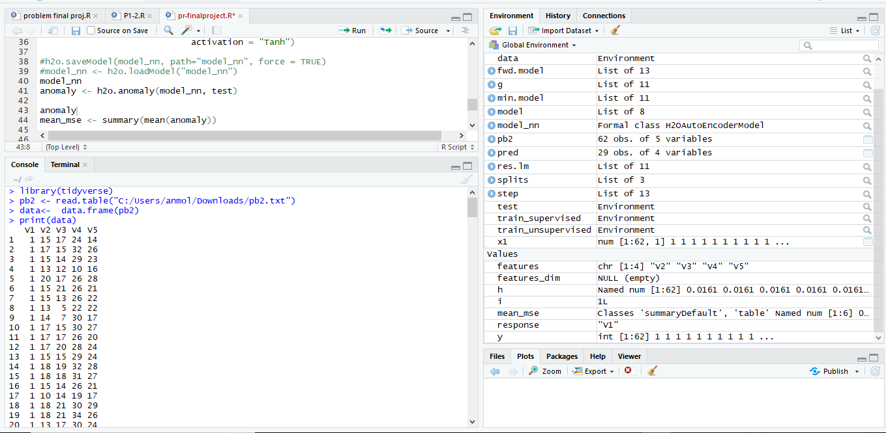

Printing summary of our dataset and also separately for class 1.

summary(data)

summary(data[data$V1 == "1", ])

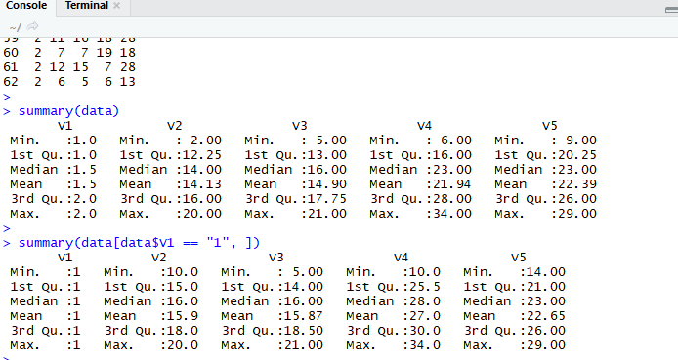

Below code shows how we will get connected to h2o cluster .

h2o.init(nthreads = -1)

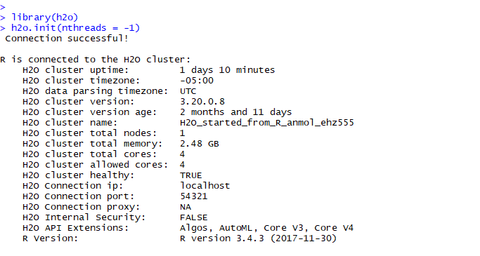

Below code shows how we will save our data to h2o cluster we created above **(H2O_started_from_R_anmol_ehz555)**.

Now we will save this data in data frame format to h2o cluster.

# convert data to H2OFrame

data <- as.h2o(data)

Now we will split the data into supervised training set and unsupervised training set and rest of it as testing set.

The ratio c(0.25,0.25) should be given less than 1 for splitting the data frame. Here 0.25 refers to 25% of dataset. So total first 50% of our dataset will go under training set(includes 25% supervised and 25% unsupervised) and rest of it as testing set.

splits <- h2o.splitFrame(data,

ratios = c(0.25, 0.25),

seed = 62)

Then we will allocate this split parts respectively to supervised , unsupervised and testing sets.

train_unsupervised <- splits[[1]]

train_supervised <- splits[[2]]

test <- splits[[3]]

Then we declare response for our class as V1 and rest columns as our features.

response <- "V1"

features <- setdiff(colnames(train_unsupervised), response)

Then we create our deep learning model using h2o.deeplearning with suitable parameters as shown below.

model_nn <- h2o.deeplearning(x = features,

training_frame = train_unsupervised,

model_id = "model_nn",

autoencoder = TRUE,

reproducible = TRUE, #slow - turn off for real problems

ignore_const_cols = FALSE,

seed = 42,

hidden = c(10, 2, 10),

epochs = 100,

activation = "Tanh")

model_nn

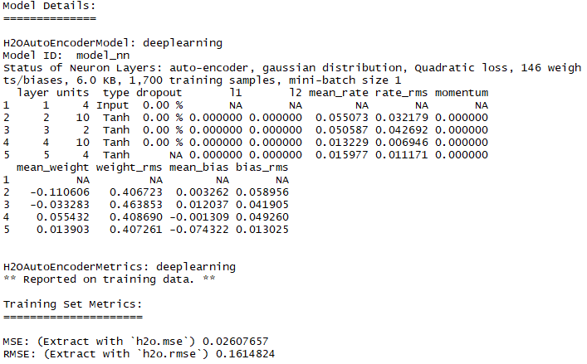

pred <- as.data.frame(h2o.predict(object = model_nn, newdata = test))

pred

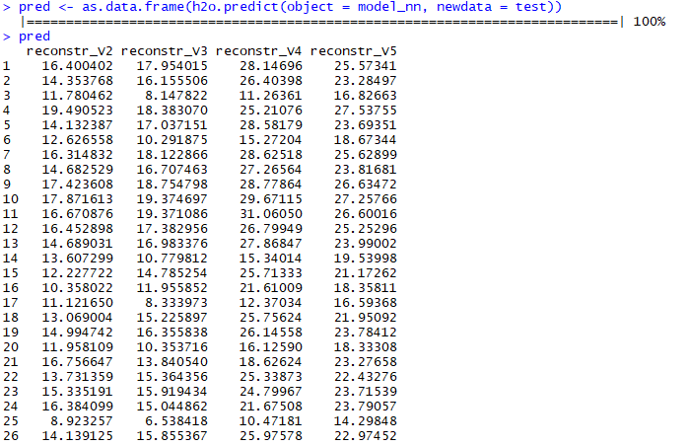

Now we will check for anomalies using h20.anomaly for our test data with the model we created above.

anomaly <- h2o.anomaly(model_nn, test)

anomaly

mean_mse <- summary(mean(anomaly))

mean_mse

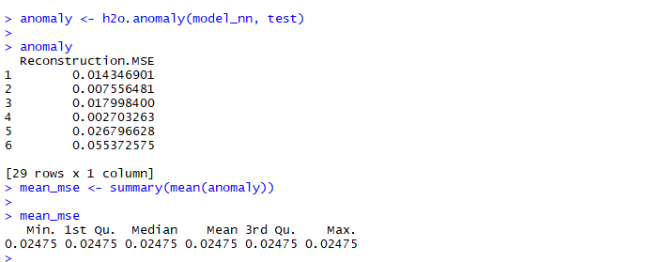

Its able to detect 29 rows x 1 col as anomalies which shows it has great accuracy and efficiency as we have total 31 anomaly/outliers points but this model was able to detect 29 of those.So I think its pretty good.

**Problem 3: PART a) SVDD.**

**Code with Explanation:**

First we are loading the required packages.

library(e1071)

library(quadprog)

Then we are going to load our Dataset.

data <- read.table("C:/Users/anmol/Downloads/pb2.txt")

#Features

X = as.matrix(data[,2:5])

y = as.matrix(data[, 1])

n <- length(y)

Then we will replace all class values by “-1” which are not “1”.

for (i in 1:n){

if (y[i] > 1){

y[i]<--1

}

}

Then we are going to define our gaussian kernel.

gaussianKern <- function(x, y, sigma){

exp(-(t(x-y)%*%(x-y))/(2*sigma^2))

}



Then we will define the function for calculating gram matrix for our dataset so that we can apply further equations which you can refer from the Question paper.

gram_mat <- function(mydat, sigma){

N <- dim(mydat)[1]

if (!is.matrix(mydat)) mydat <- as.matrix(mydat) #change class of mydat to matrix

gram_matrix <- matrix(0, N, N)

for(i in 1:N){

for(k in 1:N){

gram_matrix[i,k] <- gaussianKern(mydat[i,], mydat[k,], sigma=sigma)

}

}

print(gram_matrix)

}

You can see the output below for our training data of class 1 data with sigma = 1.5 and its respective generated gram matrix.

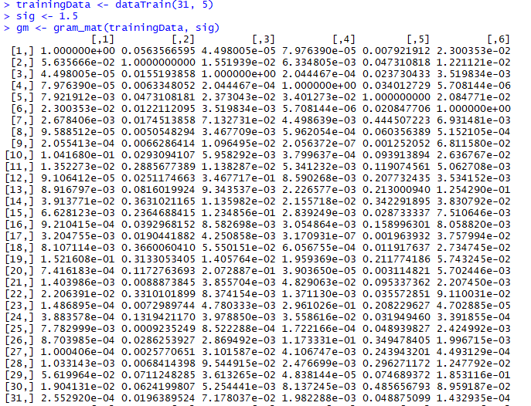

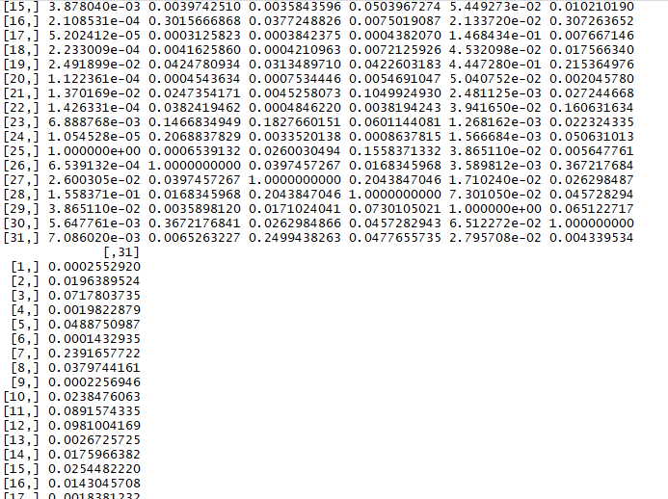

Then we are going to calculate distance of each data point and calculate the mean of that distance which you can see the output below the kernelDistance function.

kernelDistance <- function(point, data, alphas, gramMat, sigma){

#calculate the distance for a single data point in the gaussian kernel space

t1 <- gaussianKern(point, point, sigma)

t2 <- -2*sum(sapply(1:length(alphas), function(m) alphas[m]*gaussianKern(point, data[m,], sigma)))

t3 <- t(alphas) %*% gramMat %*% alphas

sqrt(t1+t2+t3)

}



Then we are going to store this a vector list of distance make.d.vec as shown below:

make.d.vec <- function(mydat, sigma){

#creates the d vector for quadprog

d <- sapply(1:dim(mydat)[1], function(m) gaussianKern(mydat[m,], mydat[m,], sigma=sigma))

print(d)

}

Now we will train our dataset for class1 data and show the plot for its respective data points after training. This will return all class1 datapoints.

dataTrain <- function(n, p, negativeProportion=0){

numNegative <- round(negativeProportion*n)

numPositive <- n-numNegative

positiveMean <- rnorm(p, mean=4, sd=1)

negativeMean <- rnorm(p, mean=-4, sd=1)

Mat <- matrix(0, p, p)

for(i in 1:p){

for(j in 1:p){

if(i==j){Mat[i, j] <- 2}

else{

Mat[i, j] <- 0.1 ^ abs(i-j)}

}

}

sigma <- Mat

positiveData <- mvrnorm(numPositive, positiveMean, sigma)

if(numNegative > 0) {

negativeData <- mvrnorm(numNegative, negativeMean, sigma)

return(rbind(positiveData, negativeData))

}

else return(positiveData)

}

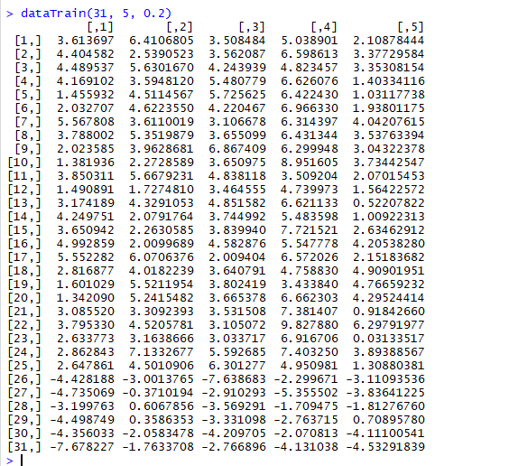

Now we are going to create a function name svddTrain to to detect all support vectors and outliers for above generated trained data and apply to it.

svddTrain <- function(X, Gram_Matrix, sigma, C1, C2=0, negativeProportion=0){

if (!is.matrix(X)) X <- as.matrix(X)

N <- dim(X)[1]

numNegative <- round(negativeProportion*N) #number of negative rows in training data

numPositive <- N-numNegative #number of positive rows in training data

d <- make.d.vec(X, sigma)

D <- gram_mat(X, sigma)

D <- 2*D

D <- D + diag(dim(D)[1])*1e-12

Then creating b, the first and second row makes sure alphas sum to 1 and others guarantee they are greater than 0.

bv <- c(1,

rep(0, N),

rep(-C1, numPositive),

rep(-C2, numNegative))

Initialize the designed A matrix to go along with bv:

A <- cbind(rep(1, N), diag(N), -diag(N))

alpha <- solve.QP(D, d, A, bv, meq=1)$solution #the alphas

non_zero_alphas <- alpha[round(alpha, digits=4) > 0]

locations <- which(round(alpha, digits=4) > 0)

support_vectors <- X[locations,]

num_SVs <- length(locations)

center <- t(alpha) %*% X

return(list(num_SVs=num_SVs,

locations=locations,

alpha=alpha,

nza=non_zero_alphas,

sv=support_vectors,

ctr=center))

}

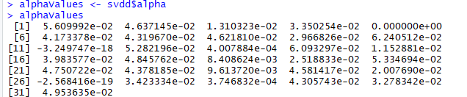

Now we are going to run svddTrain to to detect all support vectors and outliers for for our training data and apply to it. This svddTrain returns locations,alpha values and support vectors. We also see its output below with the plot of its data points.

> svddTrain(trainingData, gm, sig, 1)

[1] 1 1 1 1 1 1 1 1 1 1 1 1 1 1 1 1 1 1 1 1 1 1 1 1 1 1 1 1 1 1 1

[,1] [,2] [,3] [,4] [,5] [,6]

[1,] 1.000000e+00 0.0563566595 4.498005e-05 7.976390e-05 0.007921912 2.300353e-02

[2,] 5.635666e-02 1.0000000000 1.551939e-02 6.334805e-03 0.047310818 1.221121e-02

[3,] 4.498005e-05 0.0155193858 1.000000e+00 2.044467e-04 0.023730433 3.519834e-03

[4,] 7.976390e-05 0.0063348052 2.044467e-04 1.000000e+00 0.034012729 5.708144e-06

[5,] 7.921912e-03 0.0473108181 2.373043e-02 3.401273e-02 1.000000000 2.084771e-02

[6,] 2.300353e-02 0.0122112095 3.519834e-03 5.708144e-06 0.020847706 1.000000e+00

[7,] 2.678406e-03 0.0174513858 7.132731e-02 4.498639e-03 0.444507223 6.931481e-03

[8,] 9.588512e-05 0.0050548294 3.467709e-03 5.962054e-04 0.060356389 5.152105e-04

[9,] 2.055413e-04 0.0066286414 1.096495e-02 2.056372e-07 0.001252052 6.811580e-02

[10,] 1.041680e-01 0.0293094107 5.958292e-03 3.799637e-04 0.093913894 2.636767e-02

[11,] 1.352273e-02 0.2885677389 1.138287e-02 5.341232e-03 0.119074561 5.062708e-03

[12,] 9.106412e-05 0.0251174663 3.467717e-01 8.590268e-03 0.207732435 3.534152e-03

[13,] 8.916797e-03 0.0816019924 9.343537e-03 2.226577e-03 0.213000940 1.254290e-01

[14,] 3.913771e-02 0.3631021165 1.135982e-02 2.155718e-02 0.342291895 3.830792e-02

[15,] 6.628123e-03 0.2364688415 1.234856e-01 2.839249e-03 0.028733337 7.510646e-03

[16,] 9.210415e-04 0.0392968152 8.582698e-03 3.054864e-03 0.158996301 8.058820e-03

[17,] 3.204755e-03 0.0190441882 4.250858e-03 3.170931e-07 0.001963932 3.757994e-02

[18,] 8.107114e-03 0.3660060410 5.550151e-02 6.056755e-04 0.011917637 2.734745e-02

[19,] 1.521608e-01 0.3133053405 1.405764e-02 1.959369e-03 0.211774186 5.743245e-02

[20,] 7.416183e-04 0.1172763693 2.072887e-01 3.903650e-05 0.003114821 5.702446e-03

[21,] 1.403986e-03 0.0088873845 3.855704e-03 4.829063e-02 0.095337362 2.207450e-03

[22,] 2.206391e-02 0.3310101899 8.374154e-03 1.371130e-03 0.035572851 9.110031e-02

[23,] 1.486895e-04 0.0072989744 4.780333e-03 2.961026e-01 0.208229627 4.702885e-05

[24,] 3.883578e-04 0.1319421170 3.978850e-03 3.558616e-02 0.031949460 3.391855e-04

[25,] 7.782999e-03 0.0009235249 8.522288e-04 1.722166e-04 0.048939827 2.424992e-03

[26,] 8.703985e-04 0.0286253927 2.869492e-03 1.173331e-01 0.349478405 1.996715e-03

[27,] 1.000406e-04 0.0025770651 3.101587e-02 4.106747e-03 0.243943201 4.493129e-04

[28,] 1.033143e-03 0.0068414398 9.544915e-02 2.476699e-03 0.296271172 1.247792e-02

[29,] 5.619964e-02 0.0711248285 3.613265e-02 4.838144e-05 0.074689372 1.853116e-01

[30,] 1.904131e-02 0.0624199807 5.254441e-03 8.137245e-03 0.485656793 8.959187e-02

[31,] 2.552920e-04 0.0196389524 7.178037e-02 1.982288e-03 0.048875099 1.432935e-04

[,7] [,8] [,9] [,10] [,11] [,12]

[1,] 0.0026784064 9.588512e-05 2.055413e-04 0.1041679756 0.013522734 9.106412e-05

[2,] 0.0174513858 5.054829e-03 6.628641e-03 0.0293094107 0.288567739 2.511747e-02

[3,] 0.0713273116 3.467709e-03 1.096495e-02 0.0059582923 0.011382872 3.467717e-01

[4,] 0.0044986395 5.962054e-04 2.056372e-07 0.0003799637 0.005341232 8.590268e-03

[5,] 0.4445072233 6.035639e-02 1.252052e-03 0.0939138941 0.119074561 2.077324e-01

[6,] 0.0069314813 5.152105e-04 6.811580e-02 0.0263676699 0.005062708 3.534152e-03

[7,] 1.0000000000 3.090549e-02 6.112935e-04 0.2116499156 0.053247903 1.778645e-01

[8,] 0.0309054863 1.000000e+00 2.784073e-03 0.0009007756 0.203316834 5.346128e-02

[9,] 0.0006112935 2.784073e-03 1.000000e+00 0.0003022169 0.008701951 5.257597e-03

[10,] 0.2116499156 9.007756e-04 3.022169e-04 1.0000000000 0.017788890 5.756083e-03

[11,] 0.0532479029 2.033168e-01 8.701951e-03 0.0177888895 1.000000000 5.759832e-02

[12,] 0.1778644678 5.346128e-02 5.257597e-03 0.0057560832 0.057598316 1.000000e+00

[13,] 0.0266124314 5.457920e-02 4.835197e-02 0.0086942225 0.147428451 7.432018e-02

[14,] 0.0631652820 6.067468e-02 9.924823e-03 0.0331860697 0.457531806 8.445627e-02

[15,] 0.0368520291 2.795171e-04 1.644995e-03 0.0493647015 0.021382253 4.808078e-02

[16,] 0.0304065038 4.686361e-01 1.894726e-02 0.0021358379 0.341081877 1.187265e-01

[17,] 0.0019662982 8.992508e-03 3.265900e-01 0.0028707808 0.047026234 2.087596e-03

[18,] 0.0054309054 3.199384e-04 1.953272e-02 0.0093580522 0.028341153 2.492716e-02

[19,] 0.1457647395 4.073855e-02 1.134727e-02 0.2360369717 0.444992519 3.307777e-02

[20,] 0.0061426472 4.321480e-04 2.917714e-02 0.0050090622 0.018615479 2.878790e-02

[21,] 0.0301555210 5.538649e-05 8.519618e-06 0.0187893037 0.001202053 1.824919e-02

[22,] 0.0040930943 2.435306e-03 4.157503e-02 0.0055758307 0.075683787 2.026956e-02

[23,] 0.1327338314 1.114127e-02 3.117463e-06 0.0068148062 0.022042929 8.285618e-02

[24,] 0.0035453457 3.975289e-02 1.298149e-03 0.0002865783 0.226555027 5.243553e-02

[25,] 0.1724966089 1.617025e-04 4.794432e-06 0.4485969470 0.001091929 1.464102e-03

[26,] 0.0360169563 7.300429e-02 3.830376e-04 0.0024779266 0.102970076 1.049256e-01

[27,] 0.5571822539 9.182120e-02 1.246153e-04 0.0210524367 0.032247541 1.826250e-01

[28,] 0.5970084062 3.348726e-03 4.272065e-04 0.1426406609 0.007805329 1.577023e-01

[29,] 0.1306039031 8.256243e-03 3.836418e-02 0.3050258146 0.073556671 2.140282e-02

[30,] 0.0699719091 5.033785e-02 7.836077e-03 0.0281398913 0.130792633 6.494401e-02

[31,] 0.2391657722 3.797442e-02 2.256946e-04 0.0238476063 0.089157433 9.810042e-02

[,13] [,14] [,15] [,16] [,17] [,18]

[1,] 0.0089167974 0.039137713 0.0066281235 0.0009210415 3.204755e-03 0.0081071141

[2,] 0.0816019924 0.363102116 0.2364688415 0.0392968152 1.904419e-02 0.3660060410

[3,] 0.0093435374 0.011359815 0.1234856056 0.0085826981 4.250858e-03 0.0555015071

[4,] 0.0022265771 0.021557181 0.0028392491 0.0030548635 3.170931e-07 0.0006056755

[5,] 0.2130009403 0.342291895 0.0287333368 0.1589963014 1.963932e-03 0.0119176373

[6,] 0.1254290052 0.038307919 0.0075106462 0.0080588196 3.757994e-02 0.0273474471

[7,] 0.0266124314 0.063165282 0.0368520291 0.0304065038 1.966298e-03 0.0054309054

[8,] 0.0545792006 0.060674683 0.0002795171 0.4686360660 8.992508e-03 0.0003199384

[9,] 0.0483519666 0.009924823 0.0016449955 0.0189472599 3.265900e-01 0.0195327233

[10,] 0.0086942225 0.033186070 0.0493647015 0.0021358379 2.870781e-03 0.0093580522

[11,] 0.1474284513 0.457531806 0.0213822528 0.3410818765 4.702623e-02 0.0283411532

[12,] 0.0743201841 0.084456273 0.0480807751 0.1187265274 2.087596e-03 0.0249271624

[13,] 1.0000000000 0.549291950 0.0107648914 0.4324683060 2.722401e-02 0.0392553710

[14,] 0.5492919502 1.000000000 0.0476199459 0.3461128797 1.711253e-02 0.0810919895

[15,] 0.0107648914 0.047619946 1.0000000000 0.0025704231 1.899624e-03 0.4607869995

[16,] 0.4324683060 0.346112880 0.0025704231 1.0000000000 2.105187e-02 0.0065093950

[17,] 0.0272240065 0.017112533 0.0018996238 0.0210518719 1.000000e+00 0.0109351434

[18,] 0.0392553710 0.081091990 0.4607869995 0.0065093950 1.093514e-02 1.0000000000

[19,] 0.1627434741 0.434368944 0.0626566975 0.1055049817 7.240132e-02 0.0564389385

[20,] 0.0062809489 0.014216033 0.2999274335 0.0027414382 2.477523e-02 0.3971348515

[21,] 0.0079051391 0.022399345 0.0511193083 0.0009060003 4.020418e-06 0.0107469702

[22,] 0.3327010221 0.346894256 0.0671850985 0.0590088140 2.074952e-02 0.3611201519

[23,] 0.0055844010 0.035847364 0.0076542195 0.0142936661 8.155217e-06 0.0007772953

[24,] 0.0846771136 0.237158688 0.0090158418 0.1985801499 1.297102e-03 0.0225420076

[25,] 0.0007696002 0.002949783 0.0038780401 0.0002108531 5.202412e-05 0.0002233009

[26,] 0.2284060373 0.341369377 0.0039742510 0.3015666868 3.125823e-04 0.0041625860

[27,] 0.0097366841 0.021272999 0.0035843596 0.0377248826 3.842375e-04 0.0004210963

[28,] 0.0176156108 0.026100906 0.0503967274 0.0075019087 4.382070e-04 0.0072125926

[29,] 0.0622771853 0.081998231 0.0544927309 0.0213371995 1.468434e-01 0.0453209833

[30,] 0.7301894225 0.589538074 0.0102101899 0.3072636521 7.667146e-03 0.0175663404

[31,] 0.0026725725 0.017596638 0.0254482220 0.0143045708 1.838123e-03 0.0032060488

[,19] [,20] [,21] [,22] [,23] [,24]

[1,] 0.152160768 0.0007416183 1.403986e-03 0.0220639090 1.486895e-04 3.883578e-04

[2,] 0.313305341 0.1172763693 8.887385e-03 0.3310101899 7.298974e-03 1.319421e-01

[3,] 0.014057636 0.2072886650 3.855704e-03 0.0083741545 4.780333e-03 3.978850e-03

[4,] 0.001959369 0.0000390365 4.829063e-02 0.0013711299 2.961026e-01 3.558616e-02

[5,] 0.211774186 0.0031148210 9.533736e-02 0.0355728510 2.082296e-01 3.194946e-02

[6,] 0.057432452 0.0057024457 2.207450e-03 0.0911003122 4.702885e-05 3.391855e-04

[7,] 0.145764739 0.0061426472 3.015552e-02 0.0040930943 1.327338e-01 3.545346e-03

[8,] 0.040738551 0.0004321480 5.538649e-05 0.0024353064 1.114127e-02 3.975289e-02

[9,] 0.011347271 0.0291771414 8.519618e-06 0.0415750347 3.117463e-06 1.298149e-03

[10,] 0.236036972 0.0050090622 1.878930e-02 0.0055758307 6.814806e-03 2.865783e-04

[11,] 0.444992519 0.0186154788 1.202053e-03 0.0756837871 2.204293e-02 2.265550e-01

[12,] 0.033077768 0.0287879030 1.824919e-02 0.0202695643 8.285618e-02 5.243553e-02

[13,] 0.162743474 0.0062809489 7.905139e-03 0.3327010221 5.584401e-03 8.467711e-02

[14,] 0.434368944 0.0142160333 2.239934e-02 0.3468942563 3.584736e-02 2.371587e-01

[15,] 0.062656697 0.2999274335 5.111931e-02 0.0671850985 7.654220e-03 9.015842e-03

[16,] 0.105504982 0.0027414382 9.060003e-04 0.0590088140 1.429367e-02 1.985801e-01

[17,] 0.072401321 0.0247752284 4.020418e-06 0.0207495224 8.155217e-06 1.297102e-03

[18,] 0.056438938 0.3971348515 1.074697e-02 0.3611201519 7.772953e-04 2.254201e-02

[19,] 1.000000000 0.0272657355 6.589637e-03 0.1060170182 1.322194e-02 2.877378e-02

[20,] 0.027265736 1.0000000000 7.341909e-04 0.0454006079 2.579984e-04 5.459033e-03

[21,] 0.006589637 0.0007341909 1.000000e+00 0.0088192176 5.170017e-02 1.541946e-03

[22,] 0.106017018 0.0454006079 8.819218e-03 1.0000000000 9.902117e-04 8.253170e-02

[23,] 0.013221944 0.0002579984 5.170017e-02 0.0009902117 1.000000e+00 2.002827e-02

[24,] 0.028773783 0.0054590326 1.541946e-03 0.0825317021 2.002827e-02 1.000000e+00

[25,] 0.024918994 0.0001122361 1.370169e-02 0.0001426331 6.888768e-03 1.054528e-05

[26,] 0.042478093 0.0004543634 2.473542e-02 0.0382419462 1.466835e-01 2.068838e-01

[27,] 0.031348971 0.0007534446 4.525807e-03 0.0004846220 1.827660e-01 3.352014e-03

[28,] 0.042260318 0.0054691047 1.049925e-01 0.0038194243 6.011441e-02 8.637815e-04

[29,] 0.444727954 0.0504075205 2.481125e-03 0.0394165017 1.268162e-03 1.566684e-03

[30,] 0.215364976 0.0020457800 2.724467e-02 0.1606316336 2.232433e-02 5.063101e-02

[31,] 0.058229308 0.0150242713 1.017259e-03 0.0008364091 6.543484e-02 7.391909e-03

[,25] [,26] [,27] [,28] [,29] [,30]

[1,] 7.782999e-03 0.0008703985 0.0001000406 0.0010331432 5.619964e-02 0.019041311

[2,] 9.235249e-04 0.0286253927 0.0025770651 0.0068414398 7.112483e-02 0.062419981

[3,] 8.522288e-04 0.0028694921 0.0310158706 0.0954491486 3.613265e-02 0.005254441

[4,] 1.722166e-04 0.1173331156 0.0041067465 0.0024766985 4.838144e-05 0.008137245

[5,] 4.893983e-02 0.3494784047 0.2439432012 0.2962711722 7.468937e-02 0.485656793

[6,] 2.424992e-03 0.0019967148 0.0004493129 0.0124779172 1.853116e-01 0.089591872

[7,] 1.724966e-01 0.0360169563 0.5571822539 0.5970084062 1.306039e-01 0.069971909

[8,] 1.617025e-04 0.0730042860 0.0918212030 0.0033487262 8.256243e-03 0.050337852

[9,] 4.794432e-06 0.0003830376 0.0001246153 0.0004272065 3.836418e-02 0.007836077

[10,] 4.485969e-01 0.0024779266 0.0210524367 0.1426406609 3.050258e-01 0.028139891

[11,] 1.091929e-03 0.1029700760 0.0322475414 0.0078053293 7.355667e-02 0.130792633

[12,] 1.464102e-03 0.1049255811 0.1826250274 0.1577022811 2.140282e-02 0.064944008

[13,] 7.696002e-04 0.2284060373 0.0097366841 0.0176156108 6.227719e-02 0.730189423

[14,] 2.949783e-03 0.3413693769 0.0212729986 0.0261009065 8.199823e-02 0.589538074

[15,] 3.878040e-03 0.0039742510 0.0035843596 0.0503967274 5.449273e-02 0.010210190

[16,] 2.108531e-04 0.3015666868 0.0377248826 0.0075019087 2.133720e-02 0.307263652

[17,] 5.202412e-05 0.0003125823 0.0003842375 0.0004382070 1.468434e-01 0.007667146

[18,] 2.233009e-04 0.0041625860 0.0004210963 0.0072125926 4.532098e-02 0.017566340

[19,] 2.491899e-02 0.0424780934 0.0313489710 0.0422603183 4.447280e-01 0.215364976

[20,] 1.122361e-04 0.0004543634 0.0007534446 0.0054691047 5.040752e-02 0.002045780

[21,] 1.370169e-02 0.0247354171 0.0045258073 0.1049924930 2.481125e-03 0.027244668

[22,] 1.426331e-04 0.0382419462 0.0004846220 0.0038194243 3.941650e-02 0.160631634

[23,] 6.888768e-03 0.1466834949 0.1827660151 0.0601144081 1.268162e-03 0.022324335

[24,] 1.054528e-05 0.2068837829 0.0033520138 0.0008637815 1.566684e-03 0.050631013

[25,] 1.000000e+00 0.0006539132 0.0260030494 0.1558371332 3.865110e-02 0.005647761

[26,] 6.539132e-04 1.0000000000 0.0397457267 0.0168345968 3.589812e-03 0.367217684

[27,] 2.600305e-02 0.0397457267 1.0000000000 0.2043847046 1.710240e-02 0.026298487

[28,] 1.558371e-01 0.0168345968 0.2043847046 1.0000000000 7.301050e-02 0.045728294

[29,] 3.865110e-02 0.0035898120 0.0171024041 0.0730105021 1.000000e+00 0.065122717

[30,] 5.647761e-03 0.3672176841 0.0262984866 0.0457282943 6.512272e-02 1.000000000

[31,] 7.086020e-03 0.0065263227 0.2499438263 0.0477655735 2.795708e-02 0.004339534

[,31]

[1,] 0.0002552920

[2,] 0.0196389524

[3,] 0.0717803735

[4,] 0.0019822879

[5,] 0.0488750987

[6,] 0.0001432935

[7,] 0.2391657722

[8,] 0.0379744161

[9,] 0.0002256946

[10,] 0.0238476063

[11,] 0.0891574335

[12,] 0.0981004169

[13,] 0.0026725725

[14,] 0.0175966382

[15,] 0.0254482220

[16,] 0.0143045708

[17,] 0.0018381232

[18,] 0.0032060488

[19,] 0.0582293084

[20,] 0.0150242713

[21,] 0.0010172588

[22,] 0.0008364091

[23,] 0.0654348421

[24,] 0.0073919094

[25,] 0.0070860201

[26,] 0.0065263227

[27,] 0.2499438263

[28,] 0.0477655735

[29,] 0.0279570773

[30,] 0.0043395344

[31,] 1.0000000000

**$num_SVs**

**[1] 26**

No of support vectors shown is 26/32 at respective locations as shown below with its alpha values and support vector values based on kernelDistance.

$locations

[1] 1 2 3 4 6 8 9 10 11 12 13 15 17 18 20 21 22 23 24 25 26 27 28 29 30 31

$alpha

[1] 6.761905e-02 1.947124e-02 4.351868e-02 5.697130e-02 9.795463e-19

[6] 5.536575e-02 -7.993914e-18 5.854808e-02 5.102040e-02 2.188574e-02

[11] 2.030230e-02 2.296042e-02 7.616995e-03 3.753987e-18 3.266129e-02

[16] 0.000000e+00 4.902980e-02 1.364846e-02 -3.007983e-20 4.149972e-02

[21] 6.250726e-02 3.456631e-02 3.513547e-02 5.080233e-02 5.739913e-02

[26] 2.680857e-02 3.437704e-02 3.123471e-02 2.618228e-02 2.866640e-02

[31] 5.020126e-02

$nza

[1] 0.067619047 0.019471241 0.043518678 0.056971303 0.055365753 0.058548082

[7] 0.051020405 0.021885739 0.020302300 0.022960425 0.007616995 0.032661291

[13] 0.049029799 0.013648461 0.041499719 0.062507258 0.034566311 0.035135467

[19] 0.050802331 0.057399129 0.026808567 0.034377039 0.031234714 0.026182280

[25] 0.028666403 0.050201263

$sv

[,1] [,2] [,3] [,4] [,5]

[1,] 0.09023472 2.3894565 1.691397 6.950158 3.921643

[2,] 1.37906241 3.2362167 4.059906 4.922655 3.003185

[3,] 4.08807071 2.4537805 6.041264 4.198302 5.521934

[4,] 1.04372676 7.5862766 4.719663 4.811571 4.818272

[5,] 1.45614807 0.9926762 4.961180 8.064773 5.027954

[6,] 5.19812290 4.9735594 4.536947 7.360258 3.145646

[7,] 3.55898083 0.4370824 6.291612 7.154523 2.846151

[8,] 2.09500785 2.6548284 2.154129 6.068758 6.179375

[9,] 3.20655238 4.1304952 3.771711 6.053447 2.700670

[10,] 3.86118205 4.2695774 6.151408 5.337687 5.194869

[11,] 2.09940684 3.5855494 5.583740 7.713858 3.726197

[12,] 1.46388190 2.6015290 4.626006 3.670441 5.050181

[13,] 3.90567830 0.6485456 4.132889 7.016784 2.408257

[14,] 1.03443603 1.9694635 5.460826 4.426547 3.771847

[15,] 2.75039135 1.2640273 5.278501 3.602526 3.807367

[16,] 0.23267060 4.8180714 5.068749 5.351637 7.032550

[17,] 0.76200613 2.7240181 5.627410 6.288271 3.103929

[18,] 2.91152657 6.7297211 4.176564 5.119391 5.748137

[19,] 2.32361332 5.3841989 5.669042 5.421390 2.125571

[20,] 2.47322090 3.4638244 1.807154 6.480799 7.766715

[21,] 2.23454300 6.0199686 5.416464 7.010586 4.147629

[22,] 4.89423005 5.1064033 4.030712 6.085554 6.104440

[23,] 3.07996149 3.6295221 4.517652 5.858962 7.280738

[24,] 2.98040495 1.5677684 3.372086 6.520638 4.879424

[25,] 1.90833417 4.1937057 4.884421 7.847907 4.434470

[26,] 4.87492043 4.2686959 3.307956 4.238787 4.837835

$ctr

[,1] [,2] [,3] [,4] [,5]

[1,] 2.525036 3.525415 4.410406 5.943771 4.625282



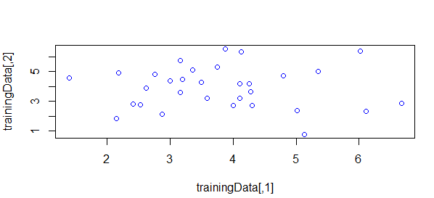

Now similarly,we are going to run svddTrain to to detect all support vectors and outliers for for entire dataset to check anomalies which are not class =1, this is nothing but out testing data and apply to it. This svddTrain returns locations,alpha values and support vectors. We also see its output below with the plot of its data points.

> svddTrain(testingData, gm, sig, 1)

[1] 1 1 1 1 1 1 1 1 1 1 1 1 1 1 1 1 1 1 1 1 1 1 1 1 1 1 1 1 1 1 1 1 1 1 1 1 1 1 1 1

[41] 1 1 1 1 1 1 1 1 1 1 1 1 1 1 1 1 1 1 1 1 1 1

[,1] [,2] [,3] [,4] [,5] [,6]

[1,] 1.000000e+00 0.080682095 4.092260e-03 0.0316790291 2.546673e-04 0.4196185834

[2,] 8.068209e-02 1.000000000 1.622451e-03 0.5842273645 8.569092e-03 0.4468272954

[3,] 4.092260e-03 0.001622451 1.000000e+00 0.0008143734 4.902086e-02 0.0040519901

[4,] 3.167903e-02 0.584227364 8.143734e-04 1.0000000000 2.254226e-02 0.1536896774

[5,] 2.546673e-04 0.008569092 4.902086e-02 0.0225422640 1.000000e+00 0.0014043553

[6,] 4.196186e-01 0.446827295 4.051990e-03 0.1536896774 1.404355e-03 1.0000000000

[7,] 1.607969e-01 0.078615411 8.105450e-02 0.0308074904 8.906221e-03 0.3306984792

[8,] 3.290242e-02 0.060176001 1.509466e-01 0.0477055175 6.004669e-02 0.1005923563

[9,] 2.397473e-03 0.012202228 1.115957e-02 0.0035645846 7.741130e-03 0.0174754297

[10,] 2.308118e-02 0.174549073 1.609956e-02 0.0484002987 7.574113e-03 0.2397910685

[11,] 7.356333e-02 0.284296787 3.077421e-03 0.2416240720 8.301903e-03 0.3835164056

[12,] 7.691849e-03 0.079540640 5.207161e-03 0.0355163050 1.292176e-02 0.0767510322

[13,] 4.250620e-03 0.057807130 2.543937e-04 0.0066428312 1.933628e-04 0.0166357188

[14,] 3.126414e-02 0.082466845 8.671618e-04 0.0350357481 1.333271e-03 0.1264996245

[15,] 1.998874e-03 0.159113975 1.483786e-03 0.2087400757 3.664697e-02 0.0475605155

[16,] 5.655104e-02 0.123019474 8.111455e-04 0.1300475915 4.525708e-03 0.0486708000

[,7] [,8] [,9] [,10] [,11] [,12]

[1,] 1.607969e-01 3.290242e-02 2.397473e-03 0.0230811831 0.0735633300 7.691849e-03

[2,] 7.861541e-02 6.017600e-02 1.220223e-02 0.1745490729 0.2842967865 7.954064e-02

[3,] 8.105450e-02 1.509466e-01 1.115957e-02 0.0160995554 0.0030774209 5.207161e-03

[4,] 3.080749e-02 4.770552e-02 3.564585e-03 0.0484002987 0.2416240720 3.551630e-02

[5,] 8.906221e-03 6.004669e-02 7.741130e-03 0.0075741129 0.0083019030 1.292176e-02

[6,] 3.306985e-01 1.005924e-01 1.747543e-02 0.2397910685 0.3835164056 7.675103e-02

[7,] 1.000000e+00 3.397384e-01 1.056451e-01 0.2615769389 0.3163062658 1.712990e-01

[8,] 3.397384e-01 1.000000e+00 1.067746e-02 0.3262367371 0.1104056821 2.789111e-02

[9,] 1.056451e-01 1.067746e-02 1.000000e+00 0.0240356186 0.0653780897 6.364446e-01

[10,] 2.615769e-01 3.262367e-01 2.403562e-02 1.0000000000 0.1644297928 7.870952e-02

[11,] 3.163063e-01 1.104057e-01 6.537809e-02 0.1644297928 1.0000000000 3.123149e-01

[12,] 1.712990e-01 2.789111e-02 6.364446e-01 0.0787095212 0.3123149205 1.000000e+00

[13,] 1.290943e-03 1.014429e-03 3.627733e-04 0.0088748846 0.0008546747 9.501391e-04

[14,] 1.133356e-01 6.283434e-03 2.668443e-01 0.0196932469 0.2982036371 5.223971e-01

[15,] 3.751869e-02 1.363452e-01 6.275514e-03 0.2226694937 0.1911870691 5.256245e-02

[16,] 1.040403e-02 2.924884e-03 4.722108e-03 0.0018946954 0.0301844313 1.498279e-02

[,13] [,14] [,15] [,16] [,17] [,18]

[1,] 4.250620e-03 3.126414e-02 1.998874e-03 5.655104e-02 1.432731e-04 1.623530e-02

[2,] 5.780713e-02 8.246684e-02 1.591140e-01 1.230195e-01 1.478035e-02 9.315897e-02

[3,] 2.543937e-04 8.671618e-04 1.483786e-03 8.111455e-04 6.030471e-04 3.127304e-06

[4,] 6.642831e-03 3.503575e-02 2.087401e-01 1.300476e-01 1.572611e-02 2.325395e-01

[5,] 1.933628e-04 1.333271e-03 3.664697e-02 4.525708e-03 7.478405e-03 1.198863e-04

[6,] 1.663572e-02 1.264996e-01 4.756052e-02 4.867080e-02 1.935651e-03 2.674568e-02

[7,] 1.290943e-03 1.133356e-01 3.751869e-02 1.040403e-02 6.684773e-04 7.465958e-04

[8,] 1.014429e-03 6.283434e-03 1.363452e-01 2.924884e-03 2.974665e-02 8.774583e-04

[9,] 3.627733e-04 2.668443e-01 6.275514e-03 4.722108e-03 9.054582e-06 1.174208e-05

[10,] 8.874885e-03 1.969325e-02 2.226695e-01 1.894695e-03 2.526823e-02 8.207771e-04

[11,] 8.546747e-04 2.982036e-01 1.911871e-01 3.018443e-02 9.052750e-04 1.589647e-02

[12,] 9.501391e-04 5.223971e-01 5.256245e-02 1.498279e-02 9.345623e-05 3.328949e-04

[13,] 1.000000e+00 9.057124e-04 6.805995e-04 1.318962e-02 2.614547e-03 8.270395e-04

[14,] 9.057124e-04 1.000000e+00 9.504935e-03 5.382390e-02 8.148539e-06 1.599056e-03

[15,] 6.805995e-04 9.504935e-03 1.000000e+00 2.010636e-03 5.092675e-02 4.809067e-03

[16,] 1.318962e-02 5.382390e-02 2.010636e-03 1.000000e+00 1.124412e-04 5.324758e-02

[,19] [,20] [,21] [,22] [,23] [,24]

[1,] 0.0746894161 0.0063363464 0.2483127823 3.180175e-03 1.300854e-04 5.504568e-03

[2,] 0.7215678658 0.2128956113 0.1392515702 5.843639e-02 1.174144e-03 3.321072e-02

[3,] 0.0062602180 0.0184274820 0.0102175187 3.799282e-02 9.449994e-03 3.893716e-03

[4,] 0.3258456864 0.0837403204 0.0305547891 3.467442e-02 6.043487e-04 1.649438e-02

[5,] 0.0119096749 0.0434236952 0.0008619446 1.278254e-01 2.327564e-02 4.579307e-03

[6,] 0.4406085304 0.0994486015 0.2573515788 1.060570e-02 4.035314e-04 6.944388e-02

[7,] 0.1267881374 0.1055619328 0.0679890217 1.037719e-02 3.058958e-03 2.542451e-01

[8,] 0.1823628741 0.2444795083 0.0607135139 3.301353e-02 6.753099e-04 6.196373e-02

[9,] 0.0088892420 0.0279482531 0.0010586018 5.783711e-03 1.144191e-01 2.229771e-01

[10,] 0.4492090760 0.6506360026 0.0862271163 2.056102e-02 3.968713e-04 1.447741e-01

[11,] 0.1969252180 0.1007637708 0.0180236759 5.017436e-03 1.242459e-03 3.837286e-01

[12,] 0.0492854840 0.0875626907 0.0032143847 8.792120e-03 3.589159e-02 4.920194e-01

[13,] 0.0667363685 0.0194001023 0.1209784228 7.636809e-02 3.779698e-04 7.348027e-05

[14,] 0.0282662610 0.0140998519 0.0041103950 2.306502e-03 1.315321e-02 1.760705e-01

[15,] 0.2201115987 0.3510535796 0.0048780927 1.115124e-02 1.859488e-04 9.310983e-02

[16,] 0.0339260597 0.0038200268 0.0242304675 3.971065e-02 9.455794e-03 1.148551e-03

[,25] [,26] [,27] [,28] [,29] [,30]

[1,] 4.106368e-05 0.0895240536 0.008226585 1.470751e-03 0.0044960068 5.265568e-05

[2,] 5.632939e-03 0.2317308144 0.490897793 1.915144e-02 0.1869016786 4.498061e-02

[3,] 1.714968e-02 0.0252306002 0.002219466 2.651381e-02 0.0011781219 6.063724e-07

[4,] 3.093100e-03 0.0435171880 0.520123698 3.970178e-03 0.0363154639 7.805410e-03

[5,] 8.114653e-02 0.0053128142 0.073600831 9.306136e-03 0.0042514171 2.719492e-05

[6,] 8.694404e-04 0.4362876209 0.085797098 7.904109e-03 0.0537890448 3.600494e-03

[7,] 2.622437e-03 0.4500170097 0.034634450 7.411252e-03 0.0180305418 1.086208e-04

[8,] 4.512590e-02 0.1384536943 0.040651336 4.570341e-02 0.0052677727 8.397570e-05

[9,] 9.490635e-04 0.1350093905 0.032167685 6.568091e-04 0.0699913266 1.915821e-04

[10,] 4.177897e-02 0.4887442635 0.075470216 6.821446e-02 0.0514657537 6.041118e-03

[11,] 9.593564e-04 0.2113217541 0.195372083 1.080220e-03 0.0320754957 1.453900e-03

[12,] 1.782117e-03 0.2378954698 0.155957039 1.093181e-03 0.1322430290 1.827721e-03

[13,] 2.610514e-03 0.0305732263 0.015880642 8.368672e-02 0.1376998134 4.011495e-02

[14,] 6.094295e-05 0.1413489964 0.077319231 1.411050e-04 0.0788665269 9.276045e-04

[15,] 3.378440e-02 0.0497323247 0.245410618 6.857194e-03 0.0158216742 5.792371e-03

[16,] 9.754470e-05 0.0166827680 0.103858183 8.037518e-04 0.0381494952 5.787983e-04

[,31] [,32] [,33] [,34] [,35] [,36]

[1,] 1.007871e-01 0.0095111237 7.657390e-02 5.540731e-03 8.318379e-04 1.349739e-01

[2,] 5.296528e-01 0.1782878312 1.339063e-02 2.217400e-01 9.382231e-02 2.005525e-02

[3,] 2.707753e-04 0.0086715804 1.218663e-01 3.349724e-04 2.654729e-04 7.772709e-03

[4,] 1.606704e-01 0.0290180278 1.522886e-03 7.026083e-01 2.415042e-01 1.295553e-02

[5,] 3.354485e-04 0.0084738245 1.000334e-03 4.143305e-02 6.230301e-02 4.642133e-04

[6,] 4.198766e-01 0.0916710804 9.161400e-02 2.877040e-02 7.505568e-03 1.017970e-01

[7,] 2.925148e-02 0.0610665411 3.021324e-01 7.147794e-03 3.262691e-03 7.993805e-02

[8,] 2.122833e-02 0.0258210021 8.867669e-02 1.352646e-02 3.617267e-03 1.868542e-01

[9,] 9.096002e-04 0.1014032287 2.593561e-02 2.189292e-03 9.611656e-03 9.823776e-05

[10,] 1.178980e-01 0.1675704393 1.045938e-01 8.142895e-03 3.282108e-03 5.396649e-02

[11,] 7.107583e-02 0.0427547730 1.551793e-02 9.738000e-02 4.671465e-02 2.068697e-02

[12,] 8.264850e-03 0.1493793123 1.811244e-02 2.094227e-02 4.905497e-02 5.555247e-04

[13,] 8.851766e-02 0.1414448225 6.241638e-03 1.542079e-03 1.131980e-03 4.031422e-04

[14,] 1.300506e-02 0.0596839645 1.065114e-02 1.867160e-02 3.099613e-02 4.938265e-04

[15,] 3.369013e-02 0.0261624501 1.541315e-03 1.034533e-01 4.659392e-02 7.774938e-03

[16,] 2.617008e-02 0.0199205904 1.974636e-03 1.329853e-01 1.028401e-01 9.499986e-04

[,37] [,38] [,39] [,40] [,41] [,42]

[1,] 2.919132e-05 5.235494e-04 3.253216e-04 0.088434888 0.0286483621 4.381194e-04

[2,] 2.576779e-03 2.080926e-02 3.127436e-02 0.539027386 0.1967413030 3.066089e-02

[3,] 2.060320e-04 1.481783e-02 6.955852e-04 0.033005146 0.1028132135 1.860555e-03

[4,] 1.318737e-04 6.022231e-02 1.216981e-02 0.378781843 0.1888293765 5.871145e-02

[5,] 5.779197e-05 3.413247e-01 9.555835e-03 0.067266704 0.2888786266 1.383021e-01

[6,] 2.066537e-03 5.863371e-03 8.738569e-03 0.297786028 0.1112810209 4.588500e-03

[7,] 2.249115e-03 2.506840e-02 1.406243e-02 0.172413252 0.2486244161 9.780939e-03

[8,] 2.463245e-03 1.972263e-01 2.835901e-03 0.318387638 0.3255342132 6.682258e-03

[9,] 1.858439e-03 5.185220e-03 3.490582e-01 0.015019742 0.1019378698 8.804897e-02

[10,] 8.632670e-02 4.488721e-02 1.795629e-02 0.275025225 0.1583775820 4.865635e-03

[11,] 7.538912e-04 5.007483e-02 4.677825e-02 0.181353292 0.2211228654 5.383653e-02

[12,] 3.142746e-03 2.129909e-02 4.897282e-01 0.057490845 0.2063281851 1.848224e-01

[13,] 2.894998e-03 5.429654e-05 1.289413e-03 0.045252812 0.0059255874 2.557540e-04

[14,] 2.215586e-04 2.080598e-03 1.542650e-01 0.029786692 0.0702290167 6.433245e-02

[15,] 4.473718e-03 3.252822e-01 2.158114e-02 0.177890736 0.1595332959 3.673682e-02

[16,] 2.865832e-06 1.136744e-03 5.949764e-03 0.083535184 0.0625572662 3.136093e-02

[,43] [,44] [,45] [,46] [,47] [,48]

[1,] 6.974247e-04 2.220697e-01 5.392337e-05 1.290946e-02 0.0090740504 3.091296e-01

[2,] 1.648904e-01 1.212592e-01 1.593986e-02 1.930887e-02 0.2180448766 2.578143e-02

[3,] 6.677560e-06 2.569189e-04 1.335606e-07 1.300300e-04 0.0047943307 5.708661e-04

[4,] 5.409358e-02 2.063219e-02 3.600052e-02 4.648998e-03 0.1103775231 3.702594e-02

[5,] 1.774203e-04 4.581684e-05 3.549057e-05 1.231934e-04 0.0341770435 2.282507e-04

[6,] 1.827275e-02 1.931265e-01 2.416237e-03 1.351838e-02 0.0783490460 1.210380e-01

[7,] 5.506144e-04 1.481338e-02 1.177111e-04 2.992643e-03 0.0699502021 6.622011e-02

[8,] 1.287735e-03 2.019741e-03 7.327266e-04 1.223074e-04 0.0204518918 1.245792e-02

[9,] 8.386318e-05 1.137221e-03 2.304216e-06 1.127732e-02 0.2863192841 1.067986e-03

[10,] 2.344995e-02 8.457515e-03 3.620064e-03 4.022057e-04 0.0576522685 3.208110e-03

[11,] 4.854607e-03 1.284673e-02 7.049524e-03 4.162590e-03 0.1739506149 1.132514e-01

[12,] 1.228549e-03 3.787143e-03 1.547154e-04 1.339650e-02 0.5429277484 5.793958e-03

[13,] 8.066188e-02 1.250651e-01 1.554934e-05 1.711969e-02 0.0133577288 4.616964e-05

[14,] 6.829195e-04 1.986870e-02 6.974822e-05 7.092708e-02 0.3244613738 3.209146e-02

[15,] 2.731158e-02 5.155821e-04 7.786203e-02 6.158259e-05 0.0547307924 1.956640e-03

[16,] 2.295732e-03 1.048668e-01 3.864400e-05 2.289588e-01 0.0937304211 3.554686e-02

[,49] [,50] [,51] [,52] [,53] [,54]

[1,] 0.0122913536 0.045591656 1.129955e-02 9.500513e-04 0.0007269035 1.068367e-01

[2,] 0.1367197791 0.224061757 1.696318e-01 4.011412e-02 0.0819034205 6.850681e-02

[3,] 0.0329237882 0.129133565 4.606127e-03 3.275075e-03 0.0162798248 1.001201e-01

[4,] 0.0689795205 0.143500611 4.025959e-01 1.902277e-02 0.0511474068 4.702384e-02

[5,] 0.0587452149 0.126472995 1.124442e-01 2.239922e-02 0.1633392149 2.500942e-02

[6,] 0.1239050593 0.173396802 6.499041e-02 1.925844e-02 0.0173837435 2.174930e-01

[7,] 0.3444181711 0.279318790 7.922390e-02 5.452744e-02 0.0338699863 8.538811e-01

[8,] 0.1982000123 0.639601799 9.159075e-02 1.423203e-02 0.1089642443 4.607360e-01

[9,] 0.3327042193 0.027680160 3.265911e-02 5.423101e-01 0.0383256960 8.365721e-02

[10,] 0.3328835812 0.395119492 4.363689e-02 4.890531e-02 0.1978965944 1.917398e-01

[11,] 0.3557554946 0.141806476 4.076807e-01 1.204858e-01 0.0445383301 3.593880e-01

[12,] 0.6129999703 0.068882999 1.609803e-01 7.633751e-01 0.0920086859 1.559806e-01

[13,] 0.0022910438 0.015323307 3.859144e-04 6.691662e-04 0.0057475881 4.847917e-04

[14,] 0.1658385391 0.019334174 8.543720e-02 2.069808e-01 0.0086785112 8.597459e-02

[15,] 0.2083036528 0.183768478 2.618400e-01 5.377243e-02 0.2818917566 6.114673e-02

[16,] 0.0100070236 0.022200752 5.064264e-02 5.398135e-03 0.0027060745 1.139121e-02

[,55] [,56] [,57] [,58] [,59] [,60]

[1,] 7.296462e-02 0.0235695524 1.562100e-01 1.360612e-04 3.091503e-03 1.390334e-04

[2,] 1.593510e-01 0.2808102421 4.872739e-02 5.074080e-02 3.154638e-02 1.787510e-02

[3,] 1.563150e-05 0.0007682442 2.327323e-01 5.408391e-07 2.028871e-05 3.427985e-04

[4,] 4.544448e-02 0.0396403597 1.263125e-02 8.822302e-03 5.215997e-03 1.052205e-02

[5,] 1.286088e-05 0.0005092094 9.211019e-03 1.720158e-05 4.057495e-05 1.364244e-02

[6,] 3.626421e-01 0.1669277120 1.390550e-01 3.974706e-03 3.420806e-02 2.282708e-03

[7,] 2.727543e-02 0.0193846156 2.768527e-01 6.956028e-05 1.097477e-02 2.640291e-03

[8,] 4.310290e-03 0.0158405984 2.172972e-01 4.442673e-05 2.789935e-04 6.084783e-04

[9,] 1.022850e-03 0.0021131289 1.371561e-02 8.316940e-05 9.033642e-02 1.273082e-01

[10,] 4.388277e-02 0.1594400871 1.116862e-01 2.325803e-03 6.123281e-03 2.238839e-03

[11,] 1.363483e-01 0.0191207410 2.608172e-02 7.852289e-04 4.949582e-02 1.163239e-02

[12,] 1.183485e-02 0.0091714994 1.524910e-02 7.627175e-04 1.920417e-01 1.608978e-01

[13,] 2.114660e-03 0.3828900073 2.071170e-02 1.217279e-01 1.411613e-03 1.700148e-03

[14,] 3.784216e-02 0.0066522122 9.479366e-03 7.463334e-04 4.135657e-01 6.961571e-02

[15,] 1.298821e-02 0.0181096514 5.416899e-03 1.613944e-03 1.670717e-03 4.814573e-03

[16,] 4.727343e-03 0.0097394871 1.608459e-02 2.373413e-03 8.098807e-03 2.000190e-02

[,61] [,62]

[1,] 0.0005958152 1.580492e-02

[2,] 0.0376922091 1.589088e-02

[3,] 0.0337916877 6.632075e-03

[4,] 0.0366617646 5.692081e-03

[5,] 0.2975788563 1.036858e-03

[6,] 0.0112021088 9.523570e-02

[7,] 0.0495629148 4.374123e-01

[8,] 0.1837058868 9.116924e-02

[9,] 0.0434980411 8.625374e-02

[10,] 0.1464772939 1.548522e-01

[11,] 0.0540366507 2.557428e-01

[12,] 0.0934805091 1.694773e-01

[13,] 0.0007154473 3.773380e-05

[14,] 0.0074040573 7.858185e-02

[15,] 0.2952552948 3.227781e-02

[16,] 0.0014669888 4.181877e-04

[ reached getOption("max.print") -- omitted 46 rows ]

$num_SVs

[1] 44

The number of support vectors shown is 44/62 whereas for our training data it was 26/32 which shows the anomalies are all the data points except the first 26 support vector points from our training data. Hence we will plot the testing data and separate those in the plot to show all the outliers.

$locations

[1] 1 3 5 8 9 10 11 13 14 15 16 17 18 21 22 23 24 25 28 29 30 31 32 33 34 35

[27] 36 37 38 39 42 43 44 45 46 48 51 53 54 55 58 59 60 62

$alpha

[1] 1.260001e-02 7.928980e-18 3.937868e-02 3.303867e-19 2.725124e-02

[6] 4.629264e-18 2.392634e-17 8.525005e-03 2.287001e-02 1.091905e-02

[11] 9.543937e-04 -2.405955e-17 3.226877e-02 9.438790e-03 2.027697e-02

[16] 2.582101e-02 4.006145e-02 4.184614e-02 5.002803e-18 2.766776e-18

[21] 1.553552e-02 2.370886e-02 3.917276e-02 1.175315e-02 2.853808e-02

[26] -8.896782e-19 6.450108e-19 2.378126e-02 8.925478e-03 2.437416e-02

[31] 6.384823e-03 5.987622e-03 3.335825e-02 1.741404e-02 1.909865e-02

[36] 3.938422e-02 4.695585e-02 2.215575e-02 1.067065e-02 -7.598505e-19

[41] 2.633815e-18 1.163496e-02 2.206666e-02 2.460702e-02 4.672418e-02

[46] 3.506823e-02 3.382477e-18 3.908869e-02 1.344536e-17 -4.845969e-18

[51] 5.666360e-03 -5.370913e-19 3.164602e-03 2.366259e-03 3.811470e-02

[56] 0.000000e+00 -1.269227e-19 1.751086e-02 3.520231e-02 1.865363e-02

[61] 8.228452e-20 3.072087e-02

$nza

[1] 0.0126000121 0.0393786841 0.0272512363 0.0085250047 0.0228700101 0.0109190533

[7] 0.0009543937 0.0322687721 0.0094387900 0.0202769712 0.0258210105 0.0400614516

[13] 0.0418461406 0.0155355164 0.0237088599 0.0391727639 0.0117531511 0.0285380785

[19] 0.0237812625 0.0089254779 0.0243741640 0.0063848230 0.0059876216 0.0333582487

[25] 0.0174140446 0.0190986518 0.0393842206 0.0469558533 0.0221557506 0.0106706535

[31] 0.0116349626 0.0220666597 0.0246070241 0.0467241752 0.0350682306 0.0390886898

[37] 0.0056663604 0.0031646016 0.0023662588 0.0381146954 0.0175108649 0.0352023061

[43] 0.0186536317 0.0307208669

$sv

[,1] [,2] [,3] [,4] [,5]

[1,] 5.5977334 5.094358 5.2633796 2.513084 5.016300

[2,] 2.6457069 1.534220 6.7260307 2.810419 3.954622

[3,] 0.7286382 2.610299 4.1238814 2.674235 2.559285

[4,] 4.0580673 2.149746 4.4068183 3.458399 3.374560

[5,] 2.2989033 4.931869 6.6891653 5.401523 2.594440

[6,] 4.2309416 2.992986 4.0164414 5.376912 4.057617

[7,] 4.3702725 5.066545 4.1463761 4.178995 2.523742

[8,] 2.3584635 4.841319 3.8018753 4.602155 7.757832

[9,] 3.5505210 6.551883 5.6362775 4.649769 2.877646

[10,] 3.3132569 3.430487 2.3200121 4.740112 2.494812

[11,] 2.4853288 6.588919 4.4606731 1.976617 4.744562

[12,] 2.7834024 1.431723 1.1413700 3.736567 5.088274

[13,] 4.4952705 6.494561 1.4605743 1.773990 4.417158

[14,] 4.5346656 3.804138 4.4251649 3.312775 6.476406

[15,] 0.9858909 3.382568 4.2383970 3.180430 5.444588

[16,] -0.1758969 4.972045 7.0224179 3.770126 3.520038

[17,] 4.0692150 4.306756 5.1483638 5.570418 1.685746

[18,] 1.1190452 1.082353 3.3339879 4.808951 4.465527

[19,] 2.2449960 1.784582 4.0040054 4.390092 6.446080

[20,] 1.8300092 5.480035 4.4633098 5.566171 5.137143

[21,] 2.2555975 5.867759 1.6915839 6.888984 5.827820

[22,] 4.7245437 5.036609 2.8394372 4.309368 5.693370

[23,] 2.2616143 4.477295 4.8412990 5.552059 5.173903

[24,] 4.4275420 3.002772 6.7839421 4.369660 5.260596

[25,] 2.3352804 5.489914 2.3283723 2.565376 3.025506

[26,] 1.0841955 5.885880 2.9817378 3.221792 2.734472

[27,] 6.2314498 2.488920 3.9805455 2.447046 4.601445

[28,] 3.1639862 2.382196 4.2154337 8.219323 5.237836

[29,] 2.3411871 2.394067 3.1488101 3.413932 1.727325

[30,] 1.3031890 5.544871 4.9710386 6.024822 2.763682

[31,] 0.8220926 5.298072 4.3167483 3.796896 1.949370

[32,] 3.0549208 4.952992 1.1812313 5.456960 5.959858

[33,] 4.4257392 6.224635 4.7275833 3.507785 6.702668

[34,] 4.8091230 4.571131 -0.4897508 4.747629 2.727548

[35,] 2.2032633 7.564829 6.0541782 3.489383 5.624492

[36,] 5.8276872 5.755722 4.8603164 1.645434 3.047184

[37,] 2.8440467 4.721104 3.5521443 3.194873 2.006617

[38,] 1.6482637 2.940950 3.6009948 5.158391 3.427722

[39,] 4.3520335 3.530744 5.4750707 3.537293 2.786150

[40,] 6.1269080 6.103999 3.2773348 4.985897 4.367119

[41,] 2.1859400 6.348908 1.8464495 6.052829 6.641536

[42,] 3.3768471 7.400949 5.3825904 6.242989 3.664693

[43,] 0.2316643 6.119836 4.9121767 5.076668 3.166442

[44,] 5.1943439 3.792195 5.6753659 5.302207 2.040370

$ctr

[,1] [,2] [,3] [,4] [,5]

[1,] 3.178484 4.39783 3.980788 4.204238 4.286701





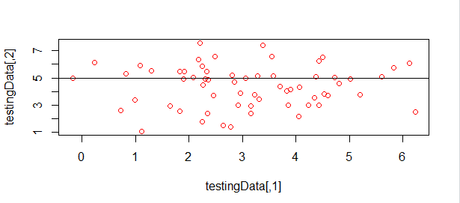

The points above the black horizontal line are detected as outliers by average KernelDistance and training Dataset. The above plot is tested on entire dataset and 6 points of even class =1 are detected as outliers which needs further rimprovements.